Managing Director, Project Manager, Exploration & Mining Advisor

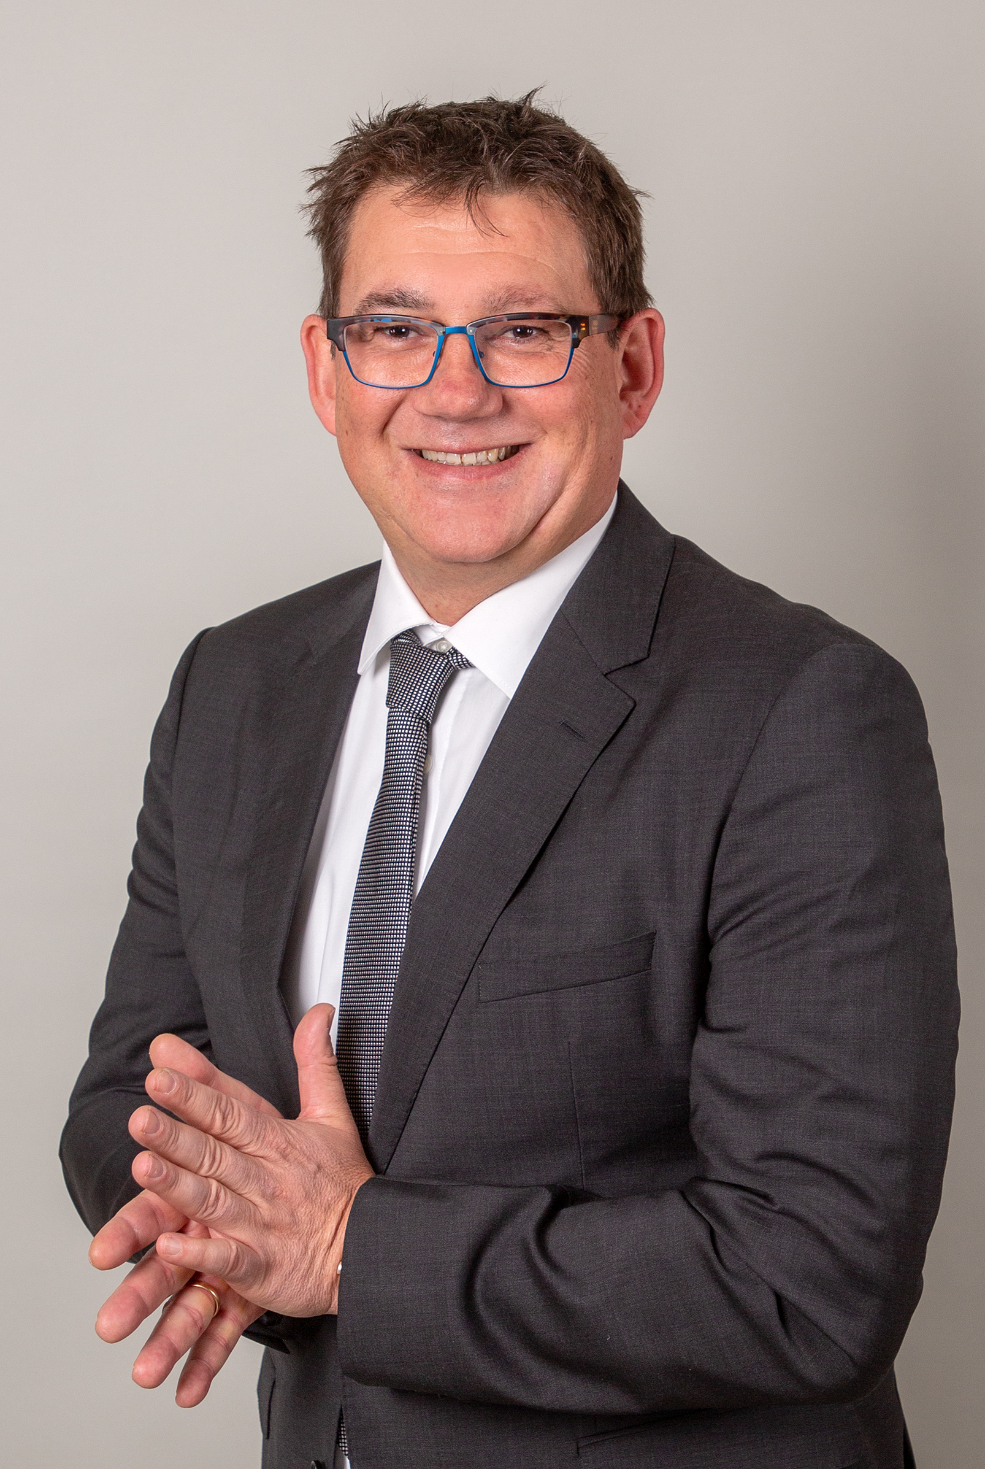
SUMMARY OF EXPERIENCE
Chris is a EurGeol geologist with more than twenty years of managerial, technical, operational and project experience in a wide range of business, cultural and climatic environments and commodities. Chris has managed development programs, pre-feasibility & bankable feasibility studies, conceptual evaluations, scoping and acquisition studies and provided technical audits for project financing. Chris’s extensive feasibility study experience has included Putu Iron Ore Project in Liberia, Horizonte Minerals Ni Project in Brazil, KHA Ta Project in Mozambique and European Nickel in Turkey and Philippines. He has led or been a key member of long-term technical development and co-operation programs at Ghana Manganese Company in Ghana, European Nickel in Albania/Serbia/Turkey/BiH, Araguaia Nickel Project in Brazil and with the ICMM in Kosovo. He has hands-on experience in the management, business development of a range of exploration, mining and consulting companies with offices in Germany, Australia, and Sri Lanka. Chris is a great visionary bringing new ideas to the mining world.PERSONAL DATA
Dipl. Geologist, Technical University Clausthal, Germany, 1995
Member of BDG (Association of German Geologists)
Member of EFG (European Federation of Geologists), EurGeol #0641
Member of SGA, Fellow of SEG
Managing Director of ECTerra PTY Ltd, Managing Director of the kRi, Managing Director of GM² German Mining & Minerals GBR. Languages – German (native speaker), English (fluent), Portuguese (good); German citizen, no travel restrictions.ACTIVITIES
Technical Evaluations of Ni, Fe, Ta, Nb, Mn, REEs, U, Mg, Li, Sn, Zn, Cr, Co, Al, Au, industrial minerals. Scoping, pre-feasibility and feasibility studies for nickel/cobalt, Iron, Tantalum/Niobium and pegmatite associated minerals projects. Transfer of Technical and Commercial know-how to modernise and (re-)develop mining enterprises. Stabilization, restructuring and privatization programs for the mining industry. Project and mining sector work on more than 30 projects in 30 countries. Working in the non-profit sector as a volunteer.COMPETENCIES
Scoping & Pre-Feasibility Studies Project Management Asset Valuations Technical Audits Director roles Owners Representation Feasibility Studies Competent Person's reports Pay Review Boards & Appeals Risk Reviews & Strategic Planning Optimisation & Post-Privatisation Support Contracts for Supplies and Services Independent Opinions for Financing Fund Raising & Business Development Construction Management Operational Management
Country Experience: - Resided/Worked in Ghana, Mozambique, Serbia, Albania, Brazil, Liberia, South Africa, Project work conducted in Albania, Brazil, Canada, China, Germany, Ghana, Greece, Liberia, Macedonia, Nigeria, Philippines, Russia, Serbia, Sri Lanka, Tajikistan, Turkey, Uganda.
Example Clients: Ghana Manganese Company Ltd, European Nickel Ltd, Horizonte Minerals Ltd, GiZ GmbH, WorldBank/IFC, KHA TEC GmbH, SaarMontan GmbH, TOTAL, Tafoli Mauretania, Empire Mining Ltd, Barrington Global Resources Ltd, FreibergCAREER HISTORY
ECTerra PTY Ltd Managing Director since 2008
German Mining & Minerals GBR Managing Director since 2019
Kollektive Rohstoff Intelligenz kRi Managing Director since 2019
Putu Iron Ore Mining Ltd/Severstal CEO Liberia 2012-2016
Horizonte Minerals Ltd Project Manager 2010-2012
European Nickel Ltd Regional Exploration Manager 2004-2010
KHA TEC GmbH Technical Director Mozambique 2003-2003
SaarMontan GmbH Project Manager Kosovo 2001-2002
Ghana Manganese Company Ltd Chief Geologist & Production Manager 1996-2000

